Pāngarau WA 5
For Parents | Ma te tamaiti e mahi
At Kaupae 5 your child should know their 2x, 5x and 10 x instantly, both x & ÷  You can test them yourself easily  3x5, 30÷5 2x8, 40÷5  3 seconds to answer – that’s instant  You can help them make a decision as to which x table they should work on - 2s,5s,10s  Do next 3x,4x,6x,7x,8x,9x  Recall all x ÷ facts to 100 | Anei te tauira  Anei te rauemi āwhina  https://www.youtube.com/watch?v=-JFcesiUTpw  Anei te mahi  Me hanga kāri pēnei  Whiria tētahi whakarea hei ako  3x 4x 6x 7x 8x 9x  Tirohia te raumei āwhina mo ngā tohutohu whakamahi.
At kaupae 5 your child should know how to skip count in 3s (& 2s,5s & 10s)  Forwards, backwards, starting with any number  Goal for fluency  Skip count smoothly  Skip count instantly  Start at any number and still be able to do it  Go up or down  Do the same with numbers up to 1000  Next  Skip count in 4s, 6s, 7s….  Skip count in fractions  ½,1/3,1/4,1/5  Eg, ¾, 4/4, 5/4….stop at 36/4  Note  Speed and fluency is important  Bigger numbers are challenging  Testing what they know and asking them know things instantly helps them to solve bigger maths problems without having to work hard on basic facts.  You can help with that by observing & ensuring the fact they choose to work on appropriate to where they are at.  You can help by expecting them to know instantly not just ‘done it’. |  | Anei te tauira  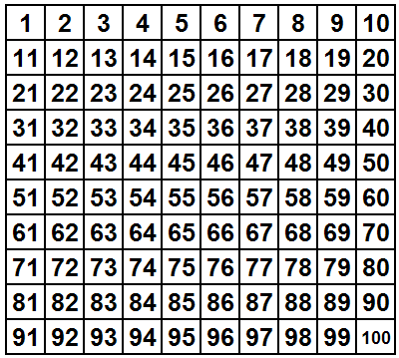  Anei te mahi  Tā i te paparau orite ki te pepa.  Timata ki 3  Kaute ia 3  Porohitatia  Kaute – ā waha kia tere  3,6,9……haere tonu  Me whanake  Timata ki tetahi atu nama penei I te 34.  Kaute ia 3.  Timata ki te tau nui ake i te 100  Mahi kia tere  Mahi ā hinengaro  Kua mohio koe he māmā te mahi ki te mahi ā hinengaro  me te whakautu tere  Whai muri I tērā  Tatau mawhitiwhiti ā 4,6,7,8 ki te 100, 200,  Tatau mawhitiwhiti mai I te 934, ā neke whakamuri….  Tatau mawhitiwhiti hautanga – ½, 2/2, 3/2, 4/2 haere tonu  He rite te mahi mo te 1/3…..1/4……1/5…..

