PĀNGARAU
KTAM: ki te tauhia i ngā nama 0-20.  Kautihia ki mua ki muri hoki.  We are learning to count numbers 0-20 backward and forward. | KTAM: k i te raupapatanga tika o ngā tauoti 0-20 mai i te mea iti iho ki te mea nui ake  we are learning how to order numbers 0-20 from the smallest number to the largest.  Anei ngā nama:  13, 6, 2, 3, 11, 1, 4  9, 1, 20, 11, 7, 13 | KTAM: ki te whakakiingia i ngā āputa. We are learning to fill the missing number.  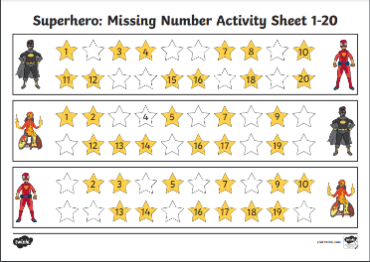 | KTAM: ki te kautihia ki te 20 mā te tuhono i ngā ira.  We are learning to count to 20 using the connect the dots picture and counting aloud as we do it. .  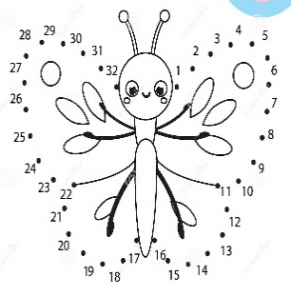 | Takaro kēmu (kāri me to whanau) Maumahara. Tuhonotia i ngā nama ōrite. Have a game of memory with your whanau see if you can match the numbers on the cards.  Ko wai te toa kei tō whānau?????  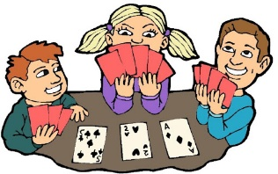

Pāngarau:
Ngohe 1:  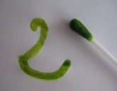  Peitahia I ēnei tau:  0,1,2,3,4,5,6,7,8,9,10  10,9,8,7,6,5,4,3,2,1,0 | Ngohe 2:  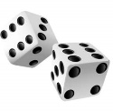  Whiua I ngā mataono tāpirihia nga nama e rua:  Tauira: 2+4=6  X10 | Ngohe 3:  Tuhi tioka:  0,2,4,6,8,10,  12,14,16,18,20 | Ngohe 4:  Peke Poraka:  10,20,30,40,50  60,70,80,90,100 | Ngohe 5:  Mahi Mōheni:  0,2,4,6,8,10  12,14,16,18,20
Ngohe 6:  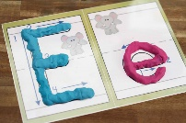  Hangaia I ēnei nama:  5,10,15,20,25,30,35,40 | Ngohe 7:  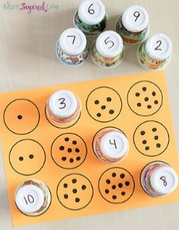  Kēmu taurite: | Ngohe 8:  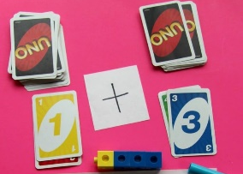  He kēmu tāpiri  X10 | Ngohe 9:  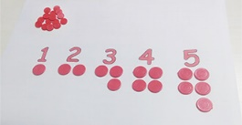  .  Hangaia I te nama mā te peruperu. | Ngohe 10:  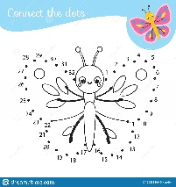  Tūhonotia i ngā nama.

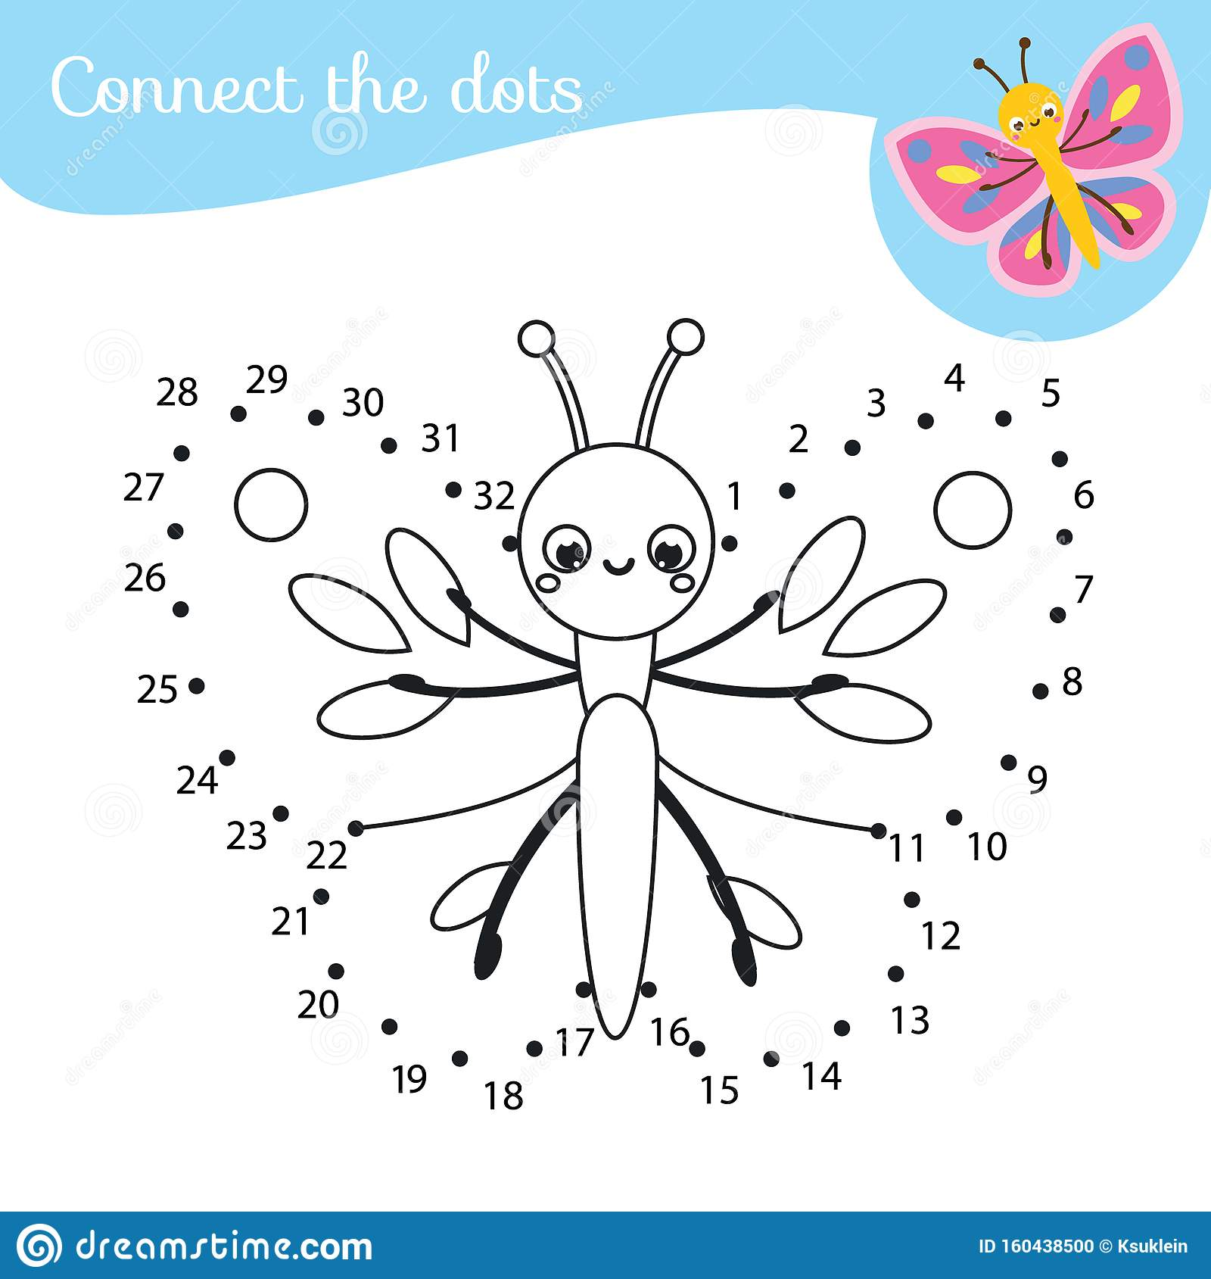
Ngohe 10: Tūhonotia I ngā nama kia tika te raupapa.
Karakarahia kia ataahua, tāpia kia tou pukapuka.

Whakakiingia i ngā āputa.

