P ā n u i |  | T u h i t u h i
Pānuihia tētahi pūrongo kōrero mai i tō niupepa-ā-Hāpori.  Read a news article from your local newspaper. | Kimihia e 5 ngā kupu hōu mai i tō pānui. Mēnā he reo pākehā te kupu, whakamāoritia te kupu.  Search for new words in the article that you have just read. If the words are in english, translate words to Māori. | Tuhia mai kia 5 ngā rerenga mō ia kupu. Hei te mutunga iho me 25 nui ake rānei ngā rerenga.  Write 5 sentences using each of your new words. You should end up with a minimum of 25 sentences. | Tuhia he rīpoata o tō pūrongo kōrero.  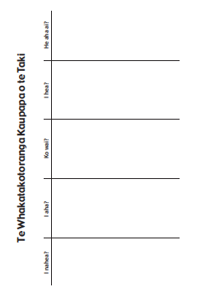  Write a report on the new article you have read. Example questions as a picture above.
Mana Māori Motuhake | P ā n g a r a u
Whakaotia kia toru o ngā ūara o te Ira Tangata.  You must complete at least three of the values from the Ira Tangata māhere. | He kōwhiringā tēnei: Uru atu ki runga i a Prodigy kia mahia e koe kia 5 nui ake rānei nga`pātai kia whakautua.  This box is optional (depending on the availability of a device or internet): Login to your Prodigy account, you must answer at least 5 questions.

Ngā Ūara o Te Ira Tangata
Huakina te tatau mō tētahi o tō whanau.  Open the door for one of your whanau  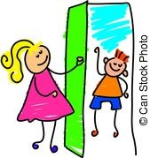 | Whakautua pai te waea, tukua hoki te mihi.  Answering the phone, using you phone manners | Pātai atu ki ngā tāngata tokorua, “Tēnā koe, i pēhea te rā?”  Ask at least 2 people how their day was.  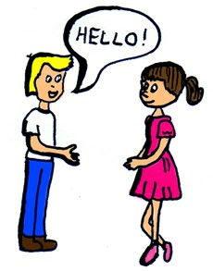 | Haria te rāpihi ia pō ki te ipupara.  Take the rubbish out every night to the bin.  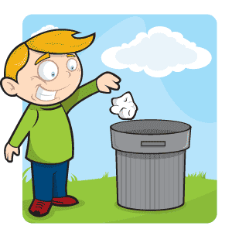
Ākona te karakia o te kura  Learn the school karakia | Ākona te kupu akiaki o te kura.  Learn the kura affirmation | Whakaritea ōku kākahu kura.  Prepare my uniform for school  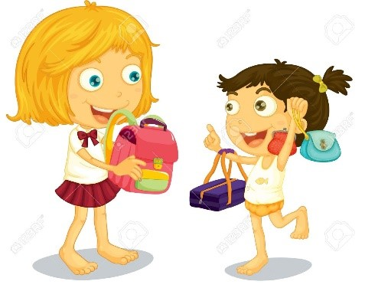 | Whakaritea tāku ake pouaka kai.  Prepare your own lunch box  