TE REO MATATINI
PĀNUI | Kōwhiri kia 3 o ngā pānuitanga mō te wiki.  Select 3 readers for the week.  Pānui ki tētahi atu. Whai whakaaro ki te whakahua tika o ia kupu.  - He aha te hononga o te pukapuka ki a koe?  Identify what connection the text has to you.  - He aha ngā kupu mahi i roto i tō pānuitanga.  Identify all of the verbs from within the text.  - Tuhia ngā kupu mahi hei rerenga kōrero.  Using all of the verbs that were identified, write them in a sentence.  Readers can be found online at “Kauwhata Reo – Ngā Kete Kōrero” Taumata 2 & 3 are appropriate levels  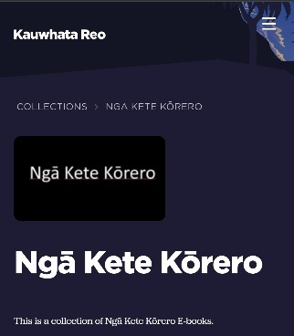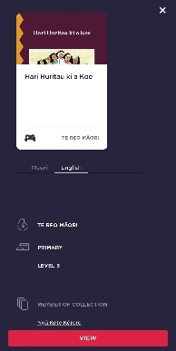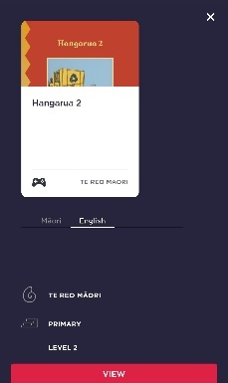
Tuhi Māhorahora | 10 miniti ia rā. Tukuna ngā whakaaro kia tuhi noa.  Free Writing for 10 minutes every day. Write continuosly for 10 minutes.  Kei a koe te kaupapa tuhituhi.  You select your own topic for free writing.  Kaupapa Tuhituhi:  Tētahi tangata rongonui – someone famous.  Ō rā whakatā - In the weekend  He kaupapa e parekareka ana ki a koe – something that you are passionate about.  Kēmu pai rawa atu – your favourite game.  Ngā āhuatanga e whakaharikoa i a koe – things that make you happy.  Ngā āhuatanga e whakararu i a koe – things that upset you.
Kōrero | Parakatihi i ngā kupu ingoa tūpou taki rua - Practice using these words in the right context.  Tāua, Māua, Rāua, Kōrua.
Tuhituhi | Ko te ‘Kupu Mahi’ te aronga o te wiki nei – Verbs are the learning focus for the week.
 | He aha te kupu mahi?  What is a verb? Write your explanation.  Tuhia kia 10 ngā kupu mahi.  Write down 10 verbs and then put them into a sentence. | Kōwhiri kia 10 ngā whakaahua mai tō whare, Tuhia te mahi o roto i te whakaahua.  Select 10 photos in your home and describe the verb in the photo.  Kei te kōrero rāua.  They are talking. | Tāngia kia 5 o ngā pikitia e whakaatu ana i tētahi mahi. Tuhia he rerenga hei tautoko i te pikitia.  Draw 5 pictures showing an action. Write a sentence using verbs to explain the action.  Kei te oma te tangata.  The person is running. | Tuhia ngā rerenga mahi e tohu ana i te wā o mua me te wā kei te heke.  Write these verbs in a present or past context.  Hopu Catch:  Wā o mua - Past:  I hopu i te pāoro. I caught the ball.  Wā kei te heke - future:  Kei te hopu i te pāoro. I am catching the ball.  Moe - sleep  Tākaro - Play  Kōrero - Talk  Tunu - Cook  Rakuraku - Scratch  Mirimiri - Massage | Hono te pikitia ki te kupu  Connect the pictures to the words.  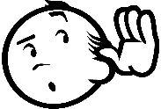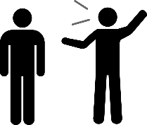  Oma Patu  Kōrero Hīkoi  Hāparangi  Whakarongo  Peita Peke  Tuhituhi  Waiata Whana

