TE REO MATATINI – Whare Ako 2
PĀNUI | Kōwhiri kia 3 o ngā pānuitanga mō te wiki.  Pānuihia, tirohia ngā pikitia rānei – mā te pakeke koe e āwhina  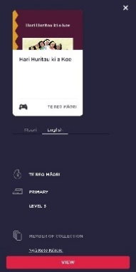  Select 3 readers for the week. Read, or study the pictures – an adult can help  - Ko wai te/ngā kiripuaki kei roto i tēnei kōrero?  Who is/are the character/s in this story?  - E pā ana tēnei pūrākau ki te aha?  What is this story about?  - Tuhia kia 3 toru ngā kupu hōu kei roto i tēnei pūrākau.  Write down 3 new words from this story.  NB: Readers can be found online at “Kauwhata Reo – Ngā Kete Kōrero” https://bit.ly/3qrjKO9  *Taumata 1 is best for our class but feel free to explore the other titles
TUHI PŪ | He tuhituhi te mahi kia 10 mēneti ia rā - hōake tātou!  Writing for 10 minutes every day – let’s go!  - Whaia tētahi pepa A4, pene hoki. Find yourself a paper and pen.  - Whakarārangitia tō pepa (kei a koe te tikanga) Rule some lines if you want.  - Tuhia tō ingoa tuatahi me te āwhina o tētahi pakeke. With the help of an adult, write your first name.  - Pānuihia ia pū o tō ingoa tuatahi, anei te tauira: “M-a-K-o-t-i”. Read each letter of your first name, eg. M-a-K-o-t-i  - Tuhia mai tō ingoa kia whakakii i ngā rārangi e 3. Anei te tauira: Write your name to fill up 3 full lines. For example:  Mā Koti Mā Koti Mā Koti Mā Koti Mā Koti Mā Koti  Mā Koti Mā Koti Mā Koti Mā Koti Mā Koti Mā Koti  Mā Koti Mā Koti Mā Koti Mā Koti Mā Koti Mā Koti  *Āta tuhituhi, kia ātaahua āu tuhinga! Whakamahia ngā ingoa o tō whānau hei whakaharatau – he ingoa rerekē ia rā, ia rā.  Write carefully for your best work! Use the names in your whānau to keep practising – a different name each day.
KŌRERO-Ā-WAHA | Whakahua i ngā kupu ingoa nei, whakatinanahia hoki.  Practice saying these words with the actions/song learnt in class  “Ko au” – (pointing inwards to yourself)  “Ko koe” – (pointing to someone in front of you)  “Ko ia” – (pointing to someone else)  “Ko tātou e” – (finger swirls in the air to include everyone in the room)  [*Find the video “Ko au, ko koe- WA2 ” on the Kura website to learn this waiata]
TAKU PUNA  KUPU  (Vocabulary development) | Anei ngā KUPU HŌU mō te wiki nei hei akoranga mā tātou – Here are our new words to learn this week
 | Tuhia mai ngā kupu hōu o te wiki ki tētahi rārangi. Anei te tauira:  Write this week’s new words in a list. For example:  Kupu hōu:  Ko  ahau  tōku  te  maunga  awa  marae  māmā  pāpā  whānau  Akona ngā kupu hōu nei ia rā ia rā mā te pānui me te panga (whakahua) i ia kupu ki tētahi pakeke.  Learn these new words every day by reading and spelling them out loud to an adult. | Kōwhiria kia 3 o ngā kupu hōu mō te wiki nei.  Choose 3 of our new words for this week.  eg. maunga, pāpā, ahau  Tāngia he pikitia mō ia kupu ki tētahi pepa kotahi.  On one piece of paper, draw a picture for each of these words.  maunga  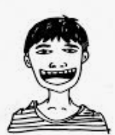  pāpā  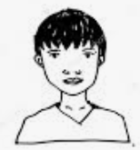  ahau | Honoa te pikitia ki te kupu tika.  Connect the picture to its word.  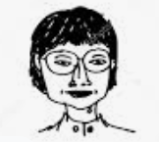 maunga  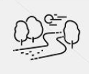 ahau  māmā  pāpā  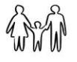 awa  whānau | Rapua tēnei pukapuka “Tōku Marae” ki te ipurangi  Find the book “Tōku Marae” on the internet  https://bit.ly/3aparst  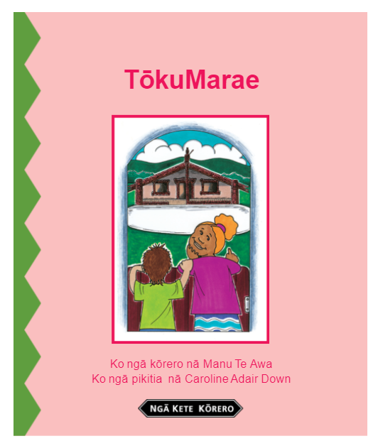  Kō ēhea o ngā kupu hōu mō tēnei wiki kei te kitea e koe ki tēnei pukapuka?  Which of our new words for this week can you find in this book?  Tuhia mai kia 3 anō ngā kupu hōu kei roto i tēnei pukapuka!  Write down 3 more new words you have found in this book!

