MĀTAURANGA TAU: KAUPAE 6
Pānuihia ēnei moni.  Read these amounts of money.  $13.45 $3.66 $0.25 $27.60 $290.87 $348.86 $0.72 $82.25 $10.80 $6.45 $1.30 $92.00 | E hia ngā 2,3,5,10 i roto i ngā tau  How many 2, 3, 5 & 10’s in these numbers.  2 3 5 10  352  673  189  462 | Whakaoti ēnei rapanga.  Answer these equations.  281+312= 512+827=  258+652= 333+444=  218+274= 276+567=  417+776= 301+637=  391+375= 272+850=  121+481= 342+657= | Whakaoti ēnei rapanga.  Answer these equations.  211-87= 343-273=  982-202= 639-292=  765-403= 829-421=  888-678= 919-788=  453-291= 879-345=  560-512= 674-362=  919-696= 569-192=
KĒMU O TE WIKI  Play the card game “Add and Multiply”. | Ngā Huinga $50.00  How many ways can you create $50.00?  $20+$20+$10=  $20+$20+$5+$5= | Pānuitia ēnei tau.  Whakaraupapa mai te tau nui ake ki te tau iti ake.  Order the numbers from biggest to smallest.  21,453 32,097 231,548  70,809 312,879 89,879  564,198 564,261 92,012  534,765 908,239 45,149 | Whakaoti ēnei rapanga, katahi huri koaro.  7x7=49÷7=7  Answer these equations using revesibility.  10x12= 11x12=  6x12= 9x7=  9x9= 7x7=  6x8= 9x11=  3x9= 5x8=
Whakaawhiwhi Ngā tauoti 10, 100 me te 1000 tata ake.  Round these numbers up to the nearest 10, 100 & 1000.  423 594 797 906  9889 254 578 2112 | Tāngia ēnei hautau a pikitia ki to pukapuka.  Draw these fractions as a picture.  1/3, 2/4, 1/5, 1/10 | WĪRA WHAKAREA:  Whakawā i to tere ki te whakakii i tētahi wīra whakarea.  Time yourself completing your multiplication wheel. | Whakautu i ēnei rapanga.  Answer these equations.  - $7.70 - $4.50  - $9.79 - $7.79  - $544 - $234  - $9.25 – $3.85  - $9.74 - $4.60  - $866 - $853

Wīra Whakarea  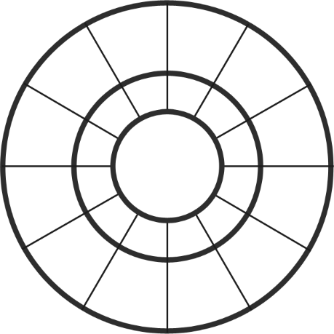  13  12  15  14  11  10  5x  9  4  8  7  6  5 | Wīra Whakarea  13  12  15  14  11  10  8x  9  4  8  7  6  5 | Wīra Whakarea  13  12  15  14  11  10  3x  9  4  8  7  6  5
Wīra Whakarea  13  12  15  14  11  10  2x  9  4  8  7  6  5 | Wīra Whakarea  13  12  15  14  11  10  4x  9  4  8  7  6  5 | Wīra Whakarea  13  12  15  14  11  10  7x  9  4  8  7  6  5
Wīra Whakarea  13  12  15  14  11  10  6x  9  4  8  7  6  5 | Wīra Whakarea  13  12  15  14  11  10  9x  9  4  8  7  6  5 | Wīra Whakarea  13  12  15  14  11  10  10x  9  4  8  7  6  5

