Wā | Mahinga | Whakamārama o te Mahi
Before 9am | Whakamoemiti-o-Ata  🙏 | Karakia-ō-ata  Hīmene  Whakatau Wairua (Meditation)
After 9am | Morning Routines | Whakapai tō moenga, horoi kanohi, paraihe niho/makawe, tīni o kākahu moe, katahi whakarite i tō parakuihi, horoi rīhi.  Make your bed, Wash face, Brush your teeth, Hair, Change out of Sleeping Clothes.  Make your own breakfast, Breakfast Clean Up.
After 10am | Oral Literacy  👄 | Puta ki waho mō ngā miniti 30 ki te kotahi hāora rānei. Kōwhiri tētahi āhuatanga o te taiao hei kaupapa kōrero mōu. Whakahua i ōna āhuatanga katoa, tuku mihi hoki. Haria i tētahi Pakeke/Kuia/Koroua mo te hīkoi, whakawhiti kōrero me tō kaumātua kia ako koe i tētahi mea hou e pā ana ki a ia.  Leave the house from 30 – 60 mins, choose a feature of the outdoors to describe and acknowledge such feature. Take a walk with an elder to give them company and learn more about them.
After 11am | Creativity | Kei a koe kotahi hāora kia puta mai tō taha auaha ma te whakamahi i ngā rawa o tō kāinga. Mahia ngā wero lego, ngā pae kēmu, waihanga taonga, tāpikitia, tunu kai, mahi pūoro rānei.  With resources found around the home give the students no more than an hour to get creative with, such as, lego challenges, board games, crafting, drawing, cooking, baking or creating music.
After 12pm | Lunch  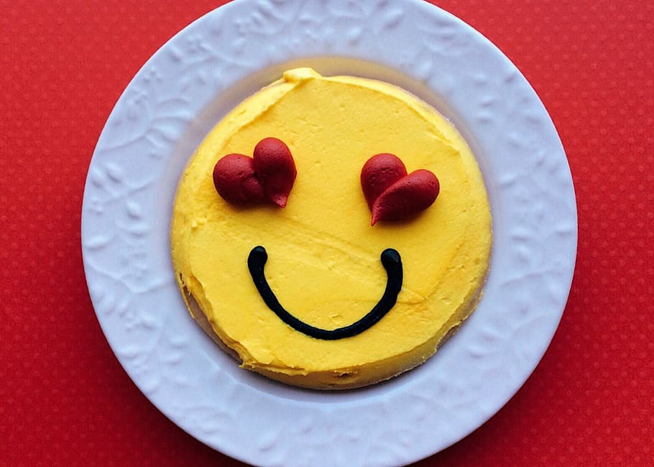 | Whakarite he kai nui i te taha o tētahi Pakeke/Kuia/Koroua rānei. Kaitahi me tō Pakeke me te whakawhiti kōrero mo ngā rā o mua. Mōu ngā rīhi e whakapai.  Cook/prepare lunch with your Elders. Have lunch with Pakeke/Kuia/Koroua (where possible). Ask questions about a time in their lives. lunchtime clean up
After 1pm | Academic Learning  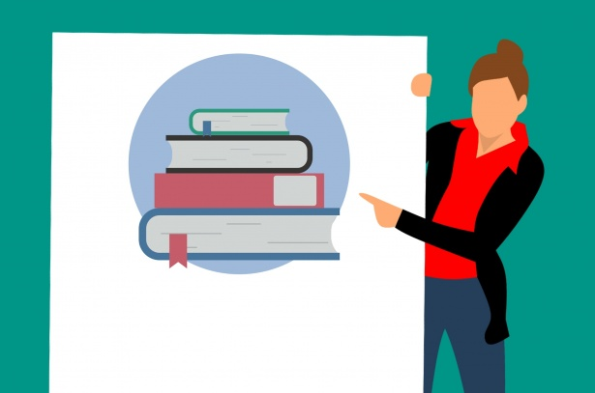 | 20 miniti tuhinga mahorahora  15 miniti pānui  30 miniti pāngarau, tākaro prodigy.  20 minutes free writing, 15 minutes reading, 30 minutes quick basic maths - Prodigy
After 2pm | Digital Learning  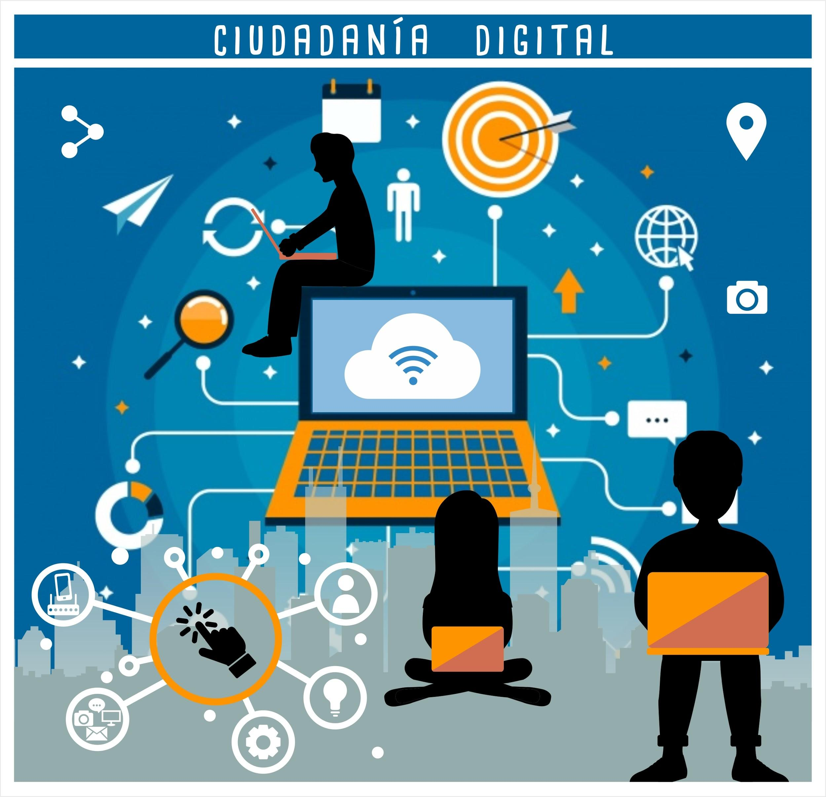 | Whakapakari pūkenga patopato, ngā ara poka o te rorohiko, te horahanga o te īmera, ētahi kēmu mātauranga ki runga i te ipurangi.  Touch typing skills, basic shortcuts on a laptop, format of an email, online educational games etc
After 2.30pm | Reflections  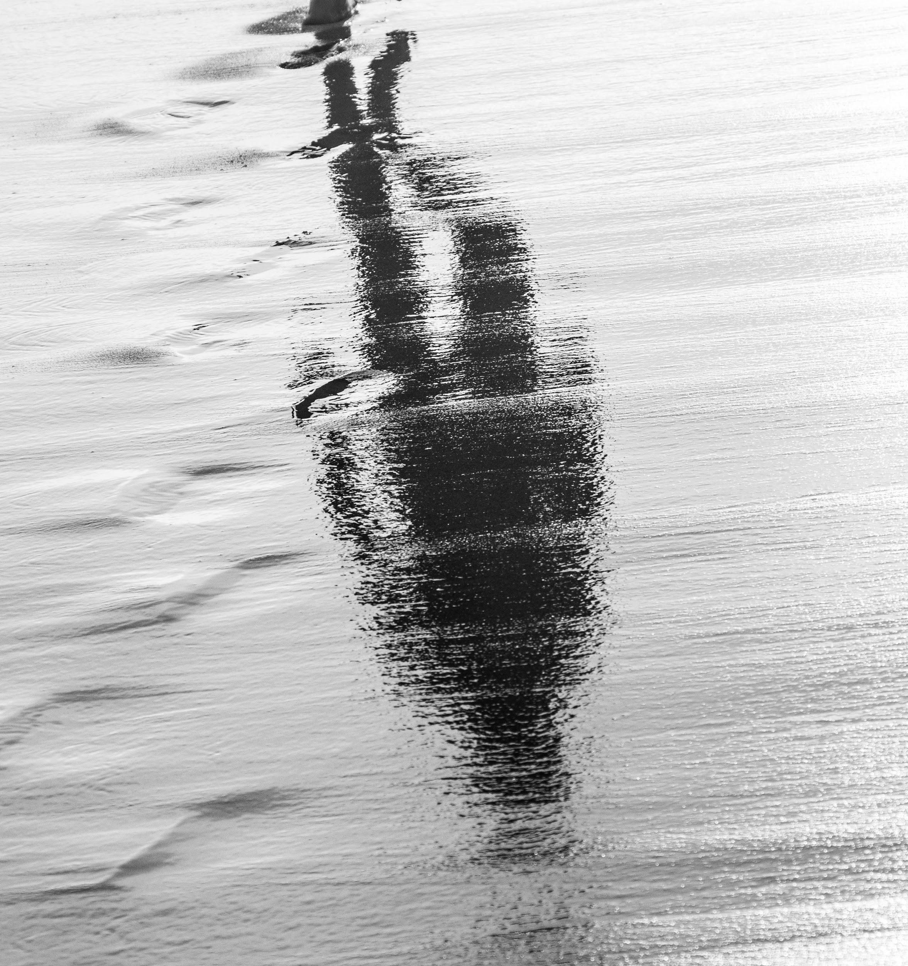 | Puta ki waho tākaro ai. Waihanga tētahi mea ki waho, kake rākau, mahi māra, whakaaroaro mō tōu rā me ngā āhuatanga o te wā. Whai whakaaro mo tētahi tohutao, mau e whakarite mo te katoa o te whānau a te wā kai nui, kai o te pō rānei. Āta whakaarohia hoki mō ngā momo ine me ngā taputapu ine ka whakamahia e koe mo tō tohutao.  Leave the house for playtime, build something outside, create something outside, climb a tree, gardening, reflect on the day and current events. Look at a recipe for tomorrow using measurements for either lunch or dinner for the whānau.
Before 3pm | Whakamoemiti-ō-Ahiahi  🙏 | Karakia whakamutunga
Apps integrated into daily activities: | The two links below will take you to the online activties your child already uses and can integrate well in to their learning programme.  https://play.prodigygame.com/  https://apps.apple.com/cn/app/he-wai-te-kai/id667665925?l=en#see-all/developer-other-apps  -He Kupu i Kore  -He Wai te Kai  We have put a list of additional links to websites, ideas and creative activities on our school website that may interest you at some stage over the next few weeks. Please feel free to check them out on www.ngatapuwae.school.nz
To Note: | Please note that these are only guidelines, there is no expectation that these will be followed.  When times are stressful, find strategies to distance yourself from your children such as having a cup of tea in your own space, by sending them out to play etc.  We know this will be a difficult time for everyone so we do not have an expectation that academic learning will continue as it would at school. But learning takes various forms and can be sitting on the couch together talking about what your schooling life was like, what your upbringing was like and allowing your child to identify what the similarities and/or differences there are.  Stay safe, stay well and enjoy the quality time you spend with your whānau

Karakia-o-Ata
E te atua
Āwhinatia ahau ki te āta noho i tēnei rā
Kia mārie, kia ngāwari noa
Kia whakawhirinaki ahau
Ki tōu kahanui
I runga i whakapono, i te whakaaio
Ki te whanga, ki te whakakite
I tāu e pai ai
I te mārie, i te māhurutanga
Ki te tutaki i ētahi atu
I runga i te rangimarie, i te ngakau hari
Ki te anga atu ki āpōpō
Ki runga i te manawatanga, i te māiatanga
Ko ihu karaiti tōku ariki
Amine

Karakia-o-Ahiahi
Auē
Auē
auē te atua
He īnoi tēnei ki a koe
Ūhia mai tō wairua tapu
Ki runga i a māto katoa auē
Auē
Auē
Kia tau…..

